Spain – March 2023

I spend hours shovelling earth and gravel to enable my car to get across the rambla.
My immediate problems are solved, but others loom. They began almost a year ago when I was in England, and the Spanish water supply company (the Gestagua) were carrying out some work in a valve pit on my land. Afterwards they presented me with an outrageous bill for water that I hadn’t used and which hadn’t leaked from my pipes. They deny all responsibility and threaten to cut off my water supply unless I pay up.

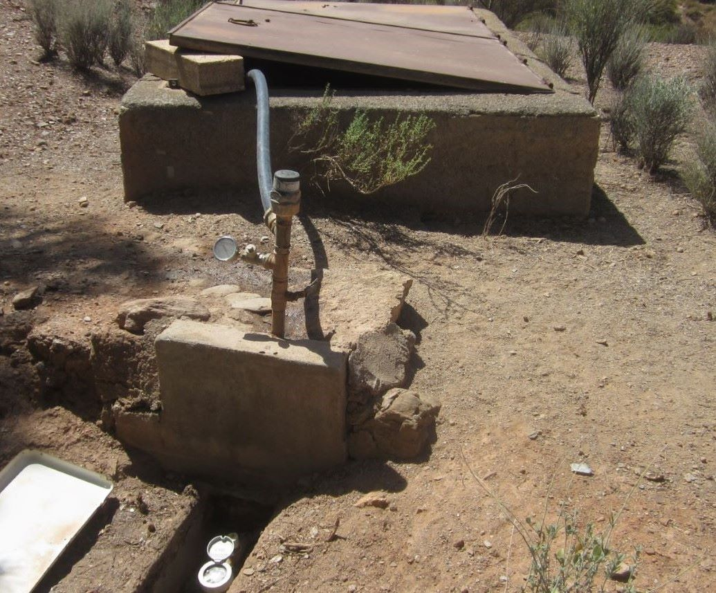

Then there is the aftermath of a break-in to deal with: It happened just before I returned here – the fourth such robbery in the fifteen years. I must also pay my Spanish income tax, and won’t get reimbursed by the UK for the tax I’ve paid them until His Majesty’s Revenue and Customs deem to do so. I am the supreme optimist, but these problems could turn me into a pessimist. Things seemed much different ten years ago . . .

